Noble Retail – Business Analysis and Requirements Gathering

# Business Process Flow Diagram

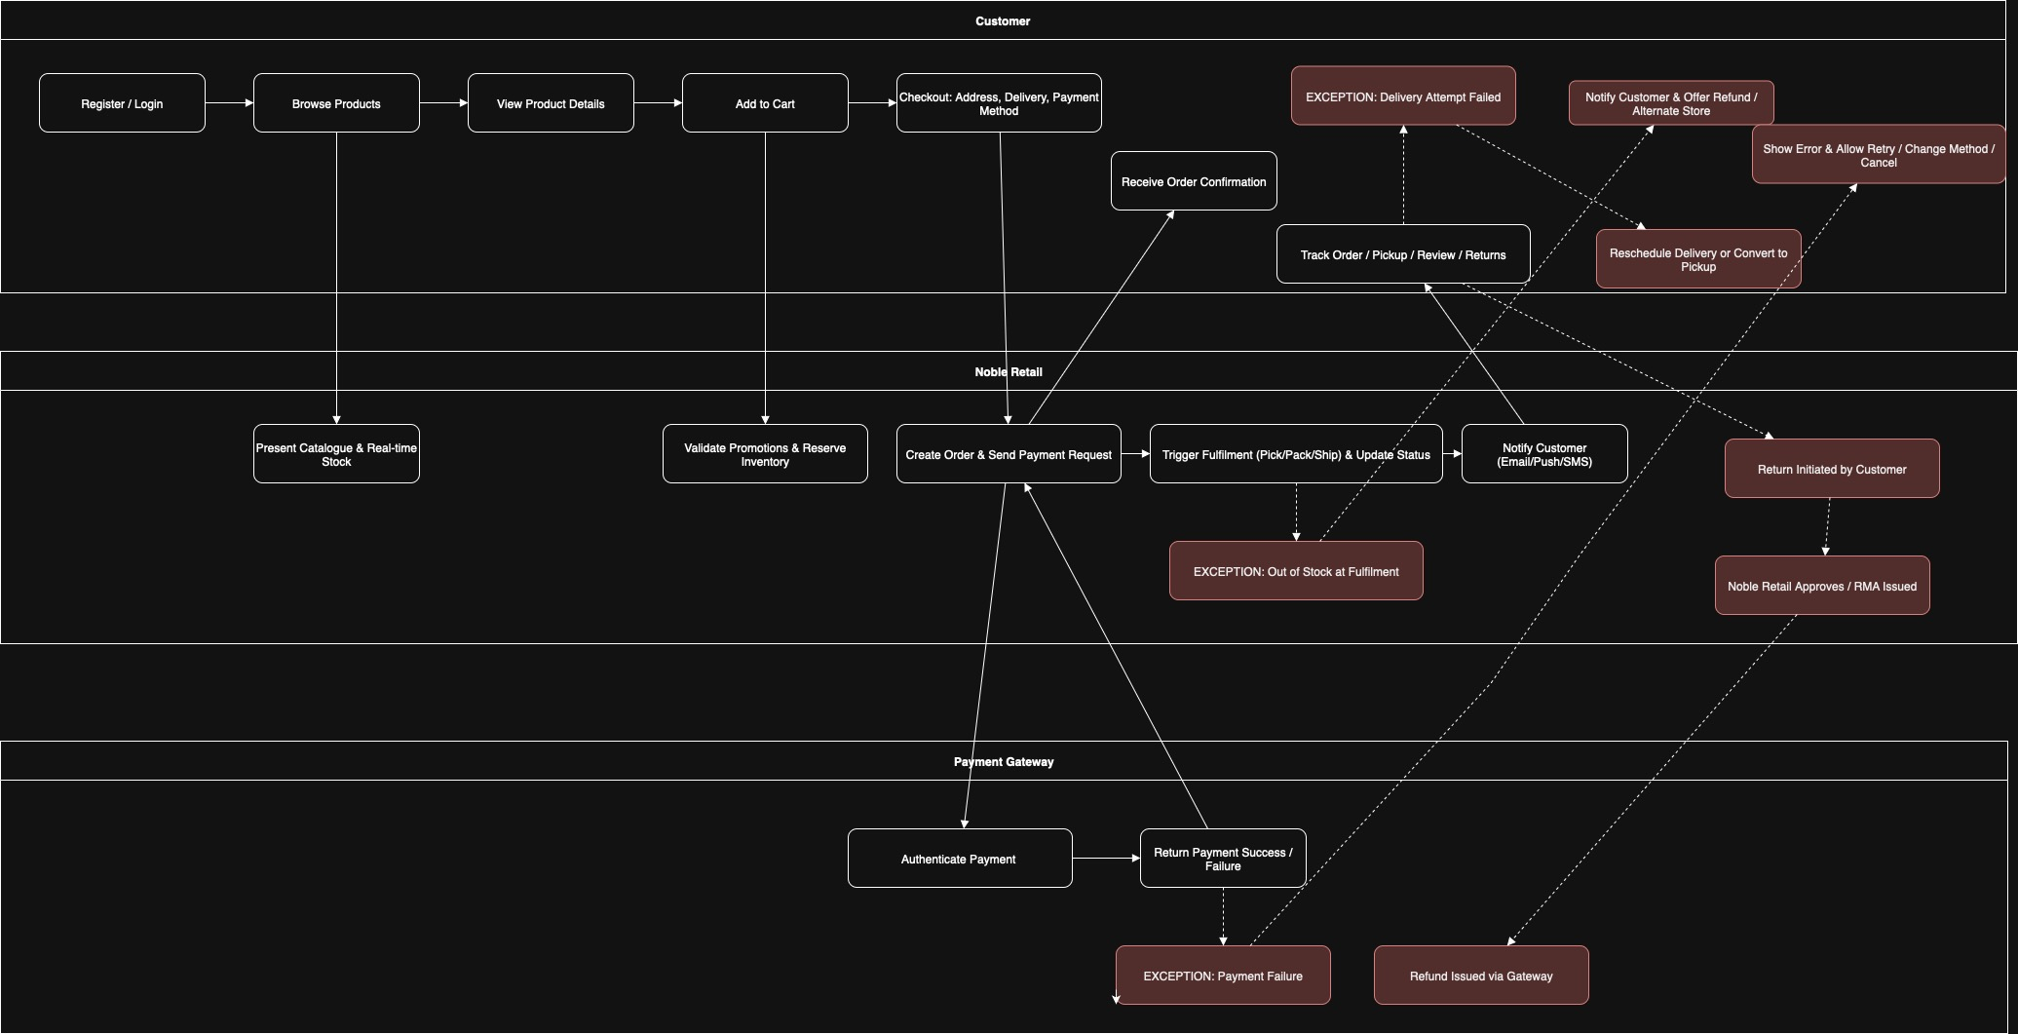

<NOBLERETAIL.drawio>

# 2. Issues / Pain Points and Basic Solutions

|  |  |  |
| --- | --- | --- |
| Pain Point | Why It’s a Problem | Basic Solution |
| Limited digital presence – only physical stores so far | Customers expect to shop anywhere, anytime; competitors already have mobile apps | Build a responsive mobile app with online catalogue, cart, checkout and payment (include local payment methods, GST display, PDPA compliance). |
| No integrated digital payment option | Slows checkout and reduces trust | Integrate secure third-party payment gateway (NETS, PayNow, GrabPay, ShopeePay) with PCI-DSS, MAS guidelines and PDPA compliance. |
| Fragmented customer data across store visits | Cannot personalise offers or run loyalty programmes effectively | Introduce a customer profile module with purchase history, preferences and SingPass/MyInfo integration for secure prefill. |
| Customer service only via call centres/in-store | No quick in-app support | Add in-app chat, FAQs, ticketing and order tracking with bilingual support (English + Chinese). |
| Marketing reach limited to traditional channels | Missed opportunities to engage mobile-first audience | Push notifications, personalised promotions, WhatsApp Business/Telegram alerts, geo-targeted offers for nearby stores. |

# 3. Business Requirements → Feature List

|  |  |
| --- | --- |
| Requirement ID | Brief Description |
| BR-1 | User registration & secure login (including social login). |
| BR-2 | Product catalogue with search, filter and personalised recommendations. |
| BR-3 | Shopping cart & Wishlist. |
| BR-4 | Secure payment gateway integration (multi-method: cards, wallets, BNPL). |
| BR-5 | Order tracking and history. |
| BR-6 | Loyalty points & rewards management. |
| BR-7 | Push notifications for promotions, order updates, and reminders. |
| BR-8 | In-app customer support (chatbot + live agent escalation). |
| BR-9 | Analytics dashboard for management (sales, active users, conversions). |
| BR-10 | Admin panel to manage inventory, offers, and content. |
| BR-11 | Security & compliance features (data privacy, encryption, tokenisation). |

### ****Assumptions****

* End users (customers) have reliable smartphones and internet connectivity to access the mobile app.
* Noble Retail will provide access to its existing product catalogue, pricing, and inventory systems via APIs or data feeds.
* Third-party payment gateways (NETS, PayNow, GrabPay, BNPL) will provide stable and secure integration APIs.
* All regulatory requirements (PDPA, MAS) are well defined at project start and will not change significantly during development.
* Stakeholders (IT, Operations, Marketing) will be available for timely feedback and approvals during sprints.
* The loyalty points/rewards system can be integrated with existing partner programs without major custom development.
* Push notification channels (WhatsApp, SMS, app notifications) will be pre-approved and accessible.

### ****Dependencies****

* Availability of secure APIs from Noble Retail’s back-end systems (inventory, orders, CRM).
* Third-party payment gateway certifications and compliance approvals.
* Timely provision of design assets, branding guidelines, and legal disclaimers by Noble Retail.
* App store approvals (Apple App Store, Google Play Store) for publishing the mobile app.
* Infrastructure readiness (servers, hosting, security certificates) in Singapore for compliance.
* Data privacy and encryption policies finalized to ensure compliance before development of secure modules.
* Integration timelines from loyalty program partners and SMS/notification providers

# 4. Top 3 Must-Have Requirements – User Stories with Acceptance Criteria

## User Story 1 – Secure Payment Gateway Integration

As a customer, I want to pay securely within the app using my preferred payment method (NETS, PayNow, GrabPay, credit/debit card) so that I can complete purchases easily and feel confident my data is safe.

* Acceptance Criteria:
* Payment page supports multiple local and international methods
* All transactions encrypted (HTTPS/TLS) and comply with MAS e-payment security guidelines
* PDPA compliance and PCI-DSS certification confirmed
* Transaction confirmation sent via email/SMS/app notification
* Payment failures show clear error message with retry option
* Prices shown in SGD inclusive of GST

## User Story 2 – Product Catalogue with Search & Personalised Recommendations

As a customer, I want to easily browse and search for products with filters so that I can quickly find items I am interested in and discover relevant recommendations with prices including GST.

* Acceptance Criteria:
* Catalogue lists all products with images, price (, description, stock status
* Search bar with auto-suggest and filters (category, price, rating)
* Recommendation engine shows at least 3 related products per viewed item
* Multilingual support (English, Chinese, Malay, Tamil) for product info
* Works seamlessly on iOS and Android devices
* Updates dynamically from backend inventory hosted in Singapore

## User Story 3 – Loyalty & Rewards Programme

As a returning customer, I want to earn and redeem loyalty points in the app so that I feel rewarded and more likely to shop again, with the option to link to local rewards programs.

* Acceptance Criteria:
* Points automatically credited after purchase
* Clear display of available points in profile
* Redemption flow at checkout (apply points to reduce bill)
* Exclusive offers for loyalty members pushed via notifications, including WhatsApp/Telegram channels
* Backend reporting for management on redemption and breakage
* Integration capability with CapitaStar/GrabRewards where feasible

# 5. User Interview Plan

## a. Goals & Expected Output

Goals:

* Understand the real pain points of current Noble Retail customers
* Learn how they shop today, their preferred local payment methods, and expectations from a retail mobile app
* Validate assumptions around loyalty features, customer service, multilingual support, and in-app navigation

Expected Output:

* Prioritised list of customer needs specific to the market
* Insights on usability expectations including local payment methods and languages
* Data to refine user stories and acceptance criteria

## b. Questions to Ask End Users

1. How do you currently shop at Noble Retail (in-store / online / social media)?
2. Have you used retail mobile apps before? Which ones?
3. What do you like / dislike about those apps?
4. How important is secure in-app payment for you? Which methods do you prefer (cards, NETS, PayNow, GrabPay)?
5. Would you link your SingPass/MyInfo to speed up registration?
6. What would make you download and continue using Noble Retail’s app?
7. How important are loyalty points, personalised offers, or integration with CapitaStar/GrabRewards to you?
8. Would you use in-app chat support instead of calling a helpline? In which language?
9. How often do you shop online vs offline?
10. Any accessibility or language preferences we should consider (English, Chinese, Malay, Tamil)?

## c. Conversation Structure

**1. Introduction & Context Setting**  
I will begin by introducing myself and explaining the purpose of the interview — to understand the user’s current shopping experience and gather input for the planned mobile application and payment gateway. I will outline the agenda, time frame, and reassure them that their feedback is confidential and valuable.

**2. Warm-up / Rapport Building**  
I will ask a few light questions about their typical shopping habits and experience with mobile apps to make them comfortable and encourage open sharing.

**3. Current Experience Exploration**  
I will then explore their current journey: how they browse products, place orders, make payments, use loyalty programs, and deal with customer support. This will help uncover pain points and unmet needs.

**4. Requirements Discovery & Deep Dive**  
I will use open-ended questions to uncover desired features, frustrations, and expectations for the new app and payment gateway. I will probe on edge cases like stock availability, payment failures, and returns to capture a complete view.

**5. Idea Validation / Feature Prioritization**  
Once needs are surfaced, I will present a few early concepts or mock-ups to gauge their reactions and preferences. I will also check which features they see as most valuable or essential.

**6. Wrap-up & Next Steps**  
Finally, I will summarize the key points discussed, verify my understanding, and explain how their input will be used. I will thank them for their time and outline any follow-up actions or feedback loops.

## d. Techniques & Tools to Facilitate

* Use journey mapping during the interview to capture steps visually
* Show low-fidelity wireframes or clickable prototypes to prompt reactions
* Record the session (with consent) for later analysis
* Use digital sticky notes (Miro board / post it) to cluster pain points and opportunities
* Employ Likert scales or card sorting for prioritisation of features